**Feedback group 29 task 43**

**by group 30**

**Task:** 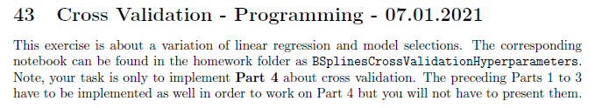

**Problems:**

**Your code isn´t running as you didn´t implement everything.**

**We believe that you hand in the wrong notebook?? Otherwise you didn´t complete the task.**

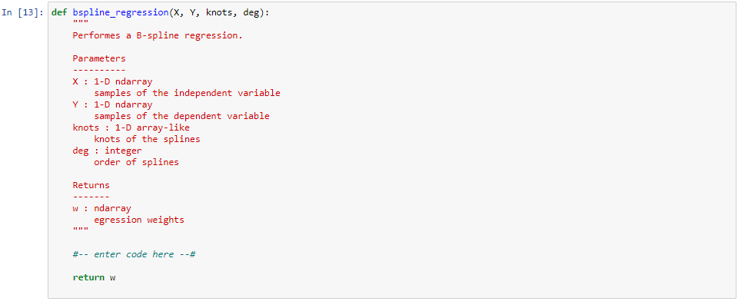

**The Inputs are missing here, the comments are telling you where to get them actually.**

